Write a C program to perform matrix addition of 2 matrices by passing the two matrices

to a user defined function. Let the called function display the addition result.

#include<stdio.h>

void addition(int r, int c, int a[50][50], int b[50][50])

{

    int sum[50][50];

    printf("The addition of both matrices is :\n");

    for (int i = 0; i < r; i++)

    {

        for (int j = 0; j < c; j++)

        {

            sum[i][j] = a[i][j] + b[i][j];

            printf(" %d ", sum[i][j]);

        }

        printf("\n");

    }

}

void main()

{

    int a[50][50], b[50][50], r, c;

    printf("Enter dimensions of the matrices: ");

    scanf("%d %d", &r, &c);

    printf("Fill matrix A\n");

    for(int i = 0; i < r; i++)

        for(int j = 0; j < c; j++)

            scanf("%d", &a[i][j]);

    printf("Fill matrix B\n");

    for(int i = 0; i < r; i++)

        for(int j = 0; j < c; j++)

            scanf("%d", &b[i][j]);

    addition(r, c, a, b);

}

Output

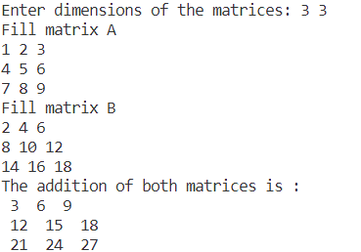

Write a C program to compute transpose of a matrix by passing it to a user defined function.

#include <stdio.h>

void transpose(int r, int c, int a[50][50])

{

    int t[50][50];

    for (int i = 0; i < r; i++)

        for (int j = 0; j < c; j++)

            t[j][i] = a[i][j];

printf("Transpose of the matrix is:\n");

  for (int i = 0; i < r; i++)

    {

        for (int j = 0; j < c; j++)

           printf("%d ", t[i][j]);

        printf("\n");

    }

}

void main()

{

    int a[50][50], r, c;

    printf("Enter dimensions of the matrix: ");

    scanf("%d %d", &r, &c);

    printf("Fill the matrix\n");

    for(int i = 0; i < r; i++)

        for(int j = 0; j < c; j++)

            scanf("%d", &a[i][j]);

    transpose(r, c, a);

}

Output

